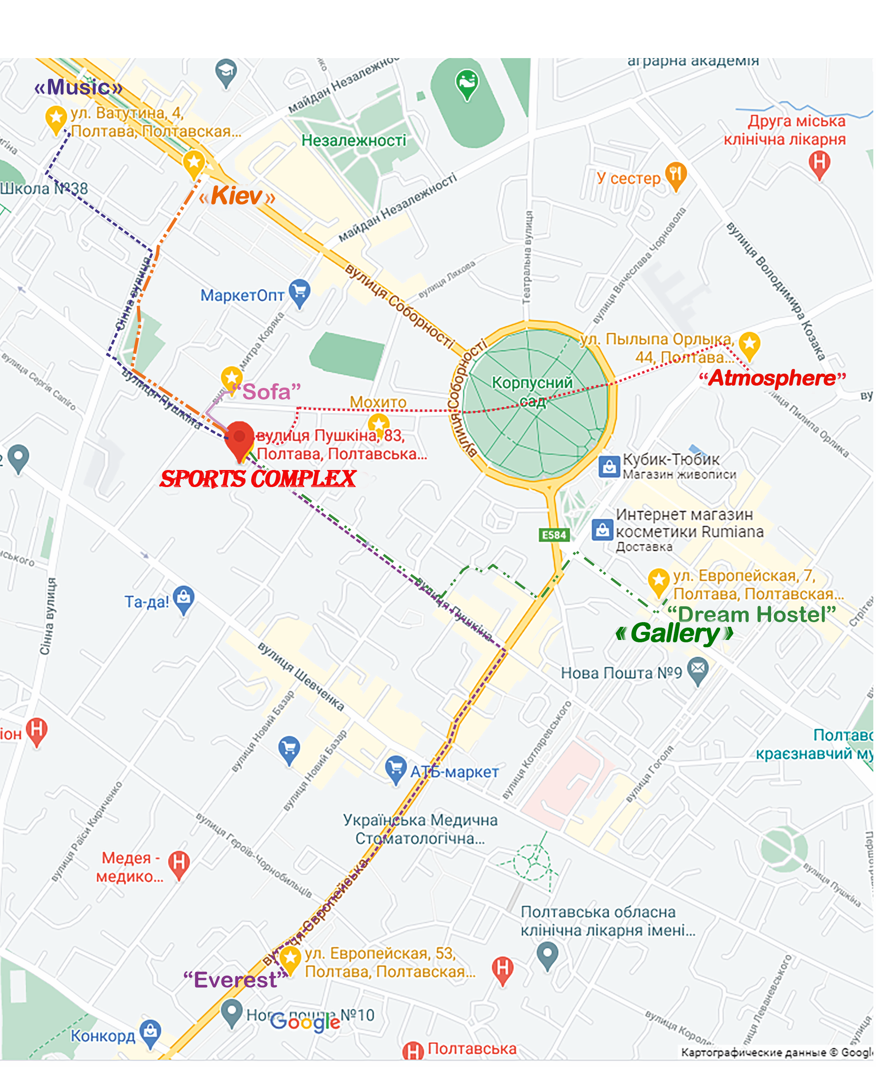

 | 1. Official hotel "Atmosphere" | 44a Pylyp Orlyka st, Poltava | Double rooms - 30 -35 Euro / room
 | "Dream hostel" | 7 Yevropeyska st, Poltava | 69 beds. - 12-15 EUR /bed
 | Hostel "Music" | 4 Vatutina st, Poltava | 35 beds. - 12-15 EUR / bed
 | Hostel "Sofa" | 12 Lidova st, Poltava | 17 beds - 10 EUR / bed
 | Hotel "Kiev" | 2 Sinna st, Poltava | 130 places: double rooms - 30 EUR / room;  Double junior suite - 35 Euro / room;  Suite - 40 EUR / room
 | Hotel "Everest" | 53 Yevropeyska st, Poltava | 30 double rooms - 35 EUR / room
 | Hotel "Gallery" | 7 Yevropeyska st, Poltava | 15 double rooms - 40-55 euros / room

For settlement issues please contact by April 1, 2021 by phone. +38 (099) 295 84 92 Roman Surkov, or
e-mail: romasdsd2011@gmail.com

